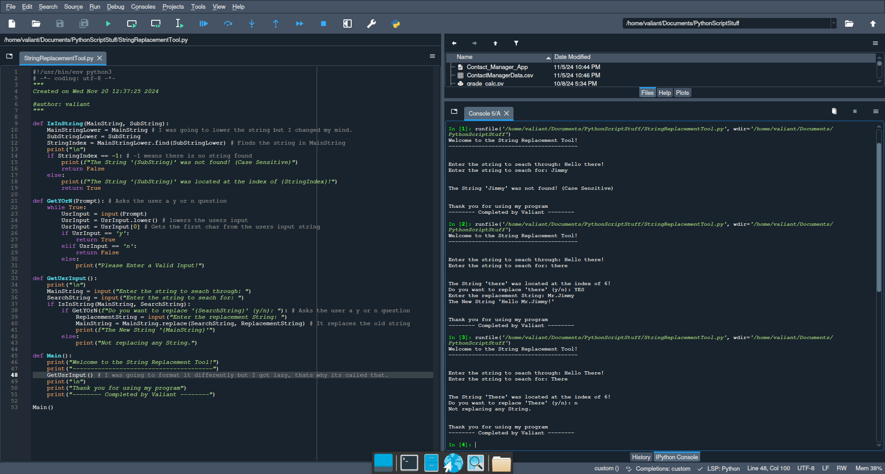(Might need to scale it down)

def IsInString(MainString, SubString):

MainStringLower = MainString # I was going to lower the string but I changed my mind.

SubStringLower = SubString

StringIndex = MainStringLower.find(SubStringLower) # Finds the string in MainString

print("\n")

if StringIndex == -1: # -1 means there is no string found

print(f"The String '{SubString}' was not found! (Case Sensitive)")

return False

else:

print(f"The String '{SubString}' was located at the index of {StringIndex}!")

return True

def GetYOrN(Prompt): # Asks the user a y or n question

while True:

UsrInput = input(Prompt)

UsrInput = UsrInput.lower() # lowers the users input

UsrInput = UsrInput[0] # Gets the first char from the users input string

if UsrInput == 'y':

return True

elif UsrInput == 'n':

return False

else:

print("Please Enter a Valid Input!")

def GetUsrInput():

print("\n")

MainString = input("Enter the string to seach through: ")

SearchString = input("Enter the string to seach for: ")

if IsInString(MainString, SearchString):

if GetYOrN(f"Do you want to replace '{SearchString}' (y/n): "): # Asks the user a y or n question

ReplacementString = input("Enter the replacement String: ")

MainString = MainString.replace(SearchString, ReplacementString) # It replaces the old string

print(f"The New String '{MainString}'")

else:

print("Not replacing any String.")

def Main():

print("Welcome to the String Replacement Tool!")

print("---------------------------------------")

GetUsrInput() # I was going to format it differently but I got lazy, thats why its called that.

print("\n")

print("Thank you for using my program")

print("-------- Completed by Valiant --------")

Main()